MACHINE LEARNING

AutoML and Hyperparameter Optimization
An Automated Approach to Model Selection and Tuning

Internship Project Report

Submitted By:
Akshitha Penakacherla
Manipal University Jaipur’ 28
CSE Data Science

Organization: Navodita Infotech
Duration: June - July

ABSTRACT
This project focuses on AutoML (Automated Machine Learning) and Hyperparameter Optimization (HPO), two closely related techniques aimed at reducing the manual effort involved in building high-performing machine learning models. Traditionally, model development requires extensive trial-and-error to select the right algorithm and fine-tune its hyperparameters — a process that is time-consuming and heavily reliant on expert intuition.
To address this, the project implements and evaluates multiple hyperparameter optimization strategies — including Grid Search, Random Search, and Bayesian Optimization — on a selected dataset, benchmarking each against a baseline model trained with default settings. The pipeline covers data preprocessing, baseline model training, definition of a hyperparameter search space, execution of automated tuning, and rigorous evaluation using cross-validation.
The results demonstrate that automated tuning methods, particularly Bayesian Optimization, consistently outperform manually configured baselines in terms of both accuracy and computational efficiency, while requiring significantly less human intervention. Beyond raw performance gains, the project highlights the practical trade-offs between exhaustive and adaptive search strategies, offering insight into how automation can be effectively integrated into real-world machine learning workflows.
Overall, this project provided hands-on experience with core AutoML/HPO concepts and tools, reinforcing the value of automation in making machine learning development faster, more consistent, and more scalable.

INTRODUCTION
Machine learning models rarely perform well out of the box. Their effectiveness depends heavily on two factors: the choice of algorithm and the specific hyperparameter values used to configure it — such as learning rate, tree depth, number of estimators, or regularization strength. Unlike model parameters, which are learned automatically during training, hyperparameters must be set manually before training begins, and their optimal values differ from one dataset and problem to the next.

THE PROBLEM
In practice, finding the right combination of algorithm and hyperparameters is a slow, repetitive, and largely manual process. Data scientists often rely on trial and error, domain intuition, or exhaustive experimentation to identify configurations that yield acceptable accuracy. This approach has several drawbacks:
- It is time consuming, especially as the number of hyperparameters and their possible values increases.
- It requires significant expertise, making it difficult for less experienced practitioners to achive optimal results.
- It does not scale well when multiple models or datasets need to be evaluated.
- Results are often inconsistent, since manual tuning is influenced by individual judgment rather than systematic search.

As machine learning is applied to increasingly complex and high-stakes problems, this manual bottleneck becomes a serious limitation — both in terms of the time it takes to reach a production-ready model and the quality of the final result.
MOTIVATION
AutoML and Hyperparameter Optimization directly address this problem by automating the search for the best-performing model configuration. Instead of relying on manual guesswork, these techniques use systematic or intelligent search strategies — such as Grid Search, Random Search, and Bayesian Optimization — to explore the hyperparameter space efficiently and identify configurations that a human might overlook or take far longer to find.
This project is relevant for several reasons:
- Industry adoption — AutoML and HPO tools (e.g., Optuna, Auto-sklearn, AutoGluon) are increasingly used in real-world ML pipelines to reduce development time and improve consistency.
- Resource efficiency — Automated tuning reduces the computational and human resources required to reach a high-performing model, which is critical as datasets and models grow larger.
- Democratization of ML — By automating expert-level tuning decisions, AutoML makes it possible for non-experts to build competitive models, lowering the barrier to entry for machine learning adoption.
- Practical, transferable skill — Understanding how these optimization techniques work under the hood — rather than just calling a library function — builds a deeper understanding of model behaviour and prepares for real-world ML engineering tasks.
By implementing and comparing these techniques on a real dataset, this project demonstrates a practical solution to a problem that is common across virtually every machine learning application: how to move from a working model to an optimized one, efficiently and reliably.
BACKGROUND
Evolution of AutoML:
The concept of AutoML emerged from a simple observation: the demand for machine learning solutions was growing far faster than the pool of experienced data scientists available to build them. Early efforts in the 2000s and early 2010s focused narrowly on automating just one part of the pipeline — hyperparameter tuning — since manually configuring even a single model was already a bottleneck.
As the field matured, the scope expanded significantly:
- First generation (hyperparameter tuning only): Tools like Grid Search and Random Search automated the search for optimal hyperparameters, but algorithm selection and feature engineering remained manual.
- Second generation (full pipeline automation): Frameworks such as Auto-WEKA and Auto-sklearn (early-to-mid 2010s) began automating algorithm selection alongside hyperparameter tuning, using Bayesian optimization to search jointly over both.
- Third generation (end-to-end AutoML): Modern platforms like AutoGluon, H2O AutoML, and Google Cloud AutoML now automate the entire workflow — data preprocessing, feature engineering, model selection, hyperparameter tuning, ensembling, and even deployment — with minimal human input.
- Current frontier (Neural Architecture Search): For deep learning specifically, AutoML has extended into automatically designing neural network architectures themselves, not just tuning their hyperparameters.
This evolution reflects a broader shift in ML development: from manual to expertise-driven tuning toward systematic, compute- driven automation.
Hyperparameter Optimization Algorithms:
Algorithm | How it Works | Strength | Limitations
Grid Search | Exhaustively evaluates every combination in a predefined parameter grid. | Simple, guaranteed to cover the defined space. | Computationally expensive; scales poorly as parameters increase.
Random  Search | Randomly samples combinations from defined distributions. | Often finds good configurations faster than Grid Search; more efficient use of a fixed budget. | No guarantee of finding the true optimum; still somewhat inefficient.
Bayesian Optimization | Builds a probabilistic surrogate model (e.g., Gaussian Process, Tree-structured Parzen Estimator) of the objective function and uses it to choose the most promising next configuration | Sample-efficient; intelligently balances exploration vs. exploitation. | More complex to implement; sequential nature limits parallelization.
Hyperband/  Successive Halving | Allocates a small budget to many configurations, then progressively eliminates poor performers and allocates more resources to promising ones. | Very efficient for large search spaces; good with limited compute. | Can prematurely discard configurations that need more time to show promise.
Evolutionary/Genetic  Algorithm | Maintains a population of configurations that evolve through selection, crossover, and mutation across generations. | Effective for complex, non-convex search spaces. | Requires many evaluations; can be slow to converge.

Existing Tools and Frameworks:
Tools | Category | Where it Fits
GridSearchCV/ RandomizedSearchCV | HPO only | Best for small, well-understood search spaces; widely used as a baseline.
Optuna | HPO library | Efficient Bayesian search with pruning; popular for its flexibility and ease of integration.
Hyperopt | HPO library | TPE-based Bayesian optimization; one of the earlier widely-adopted libraries.
Ray Tune | HPO library | Built for distributed/scalable tuning across clusters.
Auto-sklearn | Full AutoML | Automates model selection + tuning + ensembling on top of scikit-learn.
AutoGluon | Full AutoML | Strong out-of-the-box performance, supports tabular, text, and image data.
H2O AutoML | Full AutoML | Leaderboard-based comparison of many models, popular in enterprise settings.

This project sits primarily at the hyperparameter optimization layer of the AutoML spectrum — implementing and comparing Grid Search, Random Search, and Bayesian Optimization directly, rather than relying on a fully automated end-to-end AutoML framework. This positioning was intentional: by building and comparing these search strategies manually, the project provides a clearer understanding of why AutoML frameworks are effective, rather than treating them as a black box. It effectively sits between the "first generation" (pure HPO tools) and "second generation" (full pipeline automation) of AutoML evolution described above — a natural entry point for understanding the field before moving on to full AutoML platforms like Auto-sklearn or AutoGluon.

TOOLS & TECHNOLOGIES
This project was implemented using a lightweight, beginner-friendly technology stack, chosen to minimize setup overhead while covering all stages of the AutoML/HPO pipeline — from data handling to model tuning and result visualization.

Development Environment:
Google Colab was used as the primary development environment. It provides a cloud-based Jupyter Notebook with Python pre-installed, requires no local setup, and includes free access to computational resources, making it well suited for iterative experimentation.

Programming Language:
Python 3.x was used throughout the project, owing to its extensive machine learning ecosystem and ease of use.
Libraries and Frameworks:
Tool/ Library | Category | Purpose
pandas | Data handling | Loading, cleaning, and preprocessing the dataset.
Numpy | Numerical Computing | Supporting array and numerical operations used across libraries.
scikit-learn | Machine Learning | Building the baseline model; performing Grid Search and Random Search via GridSearchCV and RandomizedSearchCV.
Optuna | Hyperparameter Optimization | Implementing Bayesian Optimization for efficient hyperparameter search.
matplotlib/ seaborn | Data Visualization | Plotting baseline vs. optimized model comparisons and optimization history.

These tools were selected specifically for their balance of simplicity and capability:
- scikit-learn provides Grid Search and Random Search natively, eliminating the need for additional installation or configuration for two of the three optimization methods used.
- Optuna was chosen for Bayesian Optimization due to its minimal syntax, strong documentation, and built-in visualization support for optimization history and hyperparameter importance.
- pandas, NumPy, matplotlib, and seaborn are industry-standard libraries, ensuring the skills developed during this project are directly transferable to future machine learning work.

DATASET DESCRIPTION
The dataset used for this project is the Bengaluru House Price Dataset, sourced from Kaggle. It contains real estate listing data for properties in Bangalore, India, and is commonly used as a benchmark dataset for regression tasks involving mixed numerical and categorical features.

Attribute | Description
Source | Kaggle – “Banglore House Price Data”
Number of records | ~13,320 rows
Number of features | 9 columns
Target variable | price (property price, in lakhs INR) – continuous value
Task type | Regression
Key features | location, size, total_sqft, bath, balcony, area_type, availability
Missing values | Present in location, size, bath, and balcony – handled during preprocessing

Feature Description:
Feature | Type | Description
area_type | Categorical | Type of area listing  (e.g.,Super built-up area, Plot area)
availability | Categorical | Possession status  (e.g., Ready to Move, or a future date)
location | Categorical | Locality within Bangalore (1,000+ unique values)
size | Categorical  (text) | Number of bedrooms, e.g., "2 BHK", "3 Bedroom"
total_sqft | Numerical  (needs cleaning) | Property area — some values given as ranges (e.g., "1000–1200")
bath | Numerical | Number of bathrooms
balcony | Numerical | Number of balconies
price | Numerical  (target) | Price of the property in lakhs (INR)

- Handling missing values — rows/columns with missing location, size, bath, and balcony were imputed or dropped depending on the extent of missingness.
2. Extracting BHK count — the size column (e.g., "2 BHK", "4 Bedroom") was parsed to extract a numerical bedroom count.
3. Cleaning total_sqft — entries given as ranges (e.g., "1000–1200") were converted to their average value; non-numeric entries were removed.
4. Location grouping — since location has 1,000+ unique values, locations with very few listings were grouped into a single "Other" category to avoid excessive dimensionality after encoding.
5. Categorical encoding — location and area_type were one-hot encoded.
6. Outlier removal — properties with unrealistic price-per-square-foot values (e.g., extremely small sqft per BHK) were removed to improve model reliability.
7. Feature scaling — numerical features were scaled where required (e.g., for algorithms sensitive to feature magnitude).
8. Train-test split — data was split 80:20, ensuring the test set was held out from all tuning steps.

METHODOLOGY
This project follows a structured pipeline consisting of data preprocessing, baseline model training, hyperparameter search using three distinct strategies, and comparative evaluation. Each stage is described below.
Overall Pipeline:
Raw Dataset -> Data Preprocessing -> Train-test split -> Baseline Model -> Hyperparameter Optimization (Grid Search/Random Search/Bayesian Optimization) -> Model Evaluation -> Comparative Analysis

Data Preprocessing:
The Bengaluru House Price dataset was cleaned and transformed through the following steps before being used for model training:

- Column removal — the society column was dropped due to a high proportion of missing values.
- Missing value handling — missing entries in location, bath, and balcony were imputed using the mode/median, while rows with missing size or total_sqft were removed.
- Feature extraction — the number of bedrooms (BHK) was extracted from the size column (e.g., "2 BHK" → 2).
- Numeric cleaning — the total_sqft column, which contained both single values and ranges (e.g., "1000–1200"), was standardized by averaging range values into a single numeric figure.
- Location cardinality reduction — since the location column contained a very large number of unique categories, locations with fewer than a defined threshold of listings were grouped into a single "Other" category to prevent an excessive increase in feature dimensionality after encoding.
- Outlier removal — properties with unrealistic square-footage-per-bedroom ratios, abnormal price-per-square-foot values (calculated per location), and inconsistent bathroom-to-bedroom ratios were removed to improve data quality.
- Categorical encoding — the location, area_type, and availability columns were one-hot encoded into numerical form.
- Train-test split — the cleaned dataset was split into training (80%) and testing (20%) subsets to ensure unbiased evaluation.

Baseline Model:
A Random Forest Regressor was selected as the base algorithm for this project due to its robustness to outliers, ability to handle non-linear relationships, and strong out-of-the-box performance on tabular data. A baseline model was first trained using scikit-learn's default hyperparameters, establishing a reference performance level (R², RMSE, MAE) against which all subsequent tuning results are compared.
Hyperparameter Search Space:
A defined search space was used across all optimization methods, covering the hyperparameters expected to have the greatest impact on model performance:

Hyperparameter | Description
n_estimators | Number of trees in the forest
max_depth | Maximum depth of each tree
min_samples_split | Minimum samples required to split an internal node
min_samples_leaf | Minimum samples required at a leaf node

Hyperparameter Optimization Strategies:
Three optimization strategies were implemented and compared:
- Grid Search — exhaustively evaluated all combinations within a defined, discrete parameter grid using cross-validation, guaranteeing full coverage of the specified search space at the cost of higher computation time.
- Random Search — randomly sampled a fixed number of hyperparameter combinations from defined ranges, allowing broader exploration of the search space within a limited computational budget.
- Bayesian Optimization (Optuna) — used a Tree-structured Parzen Estimator (TPE) to model the relationship between hyperparameter values and model performance, adaptively selecting the most promising configurations to evaluate in each successive trial.
Each method was evaluated using k-fold cross-validation on the training set to ensure the reported performance did not rely on a single train-validation split, reducing the risk of overfitting to a specific data partition.
Evaluation Metrics:
Since this is a regression problem (predicting continuous house prices), the following metrics were used to evaluate and compare all models:
- R² Score — proportion of variance in price explained by the model.
- RMSE (Root Mean Squared Error) — average magnitude of prediction error, penalizing larger errors more heavily.
- MAE (Mean Absolute Error) — average magnitude of prediction error, in the same unit as price.
Comparative Analysis:
The best-performing model and configuration from each search strategy were evaluated on the held-out test set. Performance (R², RMSE, MAE) and computational cost (time taken) were recorded for all four models — Baseline, Grid Search, Random Search, and Bayesian Optimization — enabling a direct, like-for-like comparison of both model quality and search efficiency across methods.
IMPLEMENTATION
The project was implemented in Python 3.x using Google Colab as the development environment.
Baseline Model Implementation:
A Random Forest Regressor was first trained using default hyperparameters to establish a reference performance level.
from sklearn.ensemble import RandomForestRegressor
from sklearn.metrics import r2_score, mean_squared_error

baseline_model = RandomForestRegressor(random_state=42)
baseline_model.fit(X_train, y_train)

y_pred = baseline_model.predict(X_test)
baseline_r2 = r2_score(y_test, y_pred)
baseline_rmse = np.sqrt(mean_squared_error(y_test, y_pred))

This baseline achieved an R² score of 0.8075 and an RMSE of 28.01 serving as the benchmark for all subsequent optimization methods.

Grid Search Implementation:
Grid Search was implemented using scikit-learn's GridSearchCV, exhaustively evaluating combinations across a defined parameter grid with 3-fold cross-validation.

from sklearn.model_selection import GridSearchCV

grid_param_grid = {
'n_estimators': [100, 200],
'max_depth': [10, None]
}

grid_search = GridSearchCV(
estimator=RandomForestRegressor(random_state=42),
param_grid=grid_param_grid,
cv=3,
scoring='r2',
n_jobs=-1
)
grid_search.fit(X_train, y_train)

Random Search Implementation:
Random Search was implemented using RandomizedSearchCV, sampling a fixed number of hyperparameter combinations from a wider distribution than Grid Search.

from sklearn.model_selection import RandomizedSearchCV

random_param_dist = {
'n_estimators': [100, 150, 200, 250],
'max_depth': [10, 15, 20, None],
'min_samples_split': [2, 5, 10],
'min_samples_leaf': [1, 2, 4]
}

random_search = RandomizedSearchCV(
estimator=RandomForestRegressor(random_state=42),
param_distributions=random_param_dist,
n_iter=10,
cv=3,
scoring='r2',
n_jobs=-1,
random_state=42
)
random_search.fit(X_train, y_train)

Bayesian Optimization Implementation:
Bayesian Optimization was implemented using the Optuna library, which uses a Tree-structured Parzen Estimator to adaptively select promising hyperparameter combinations across successive trials.
import optuna
from sklearn.model_selection import cross_val_score

def objective(trial):
n_estimators = trial.suggest_int('n_estimators', 100, 300)
max_depth = trial.suggest_int('max_depth', 5, 20)
min_samples_split = trial.suggest_int('min_samples_split', 2, 10)
min_samples_leaf = trial.suggest_int('min_samples_leaf', 1, 5)

model = RandomForestRegressor(
n_estimators=n_estimators, max_depth=max_depth,
min_samples_split=min_samples_split, min_samples_leaf=min_samples_leaf,
random_state=42, n_jobs=-1
)
return cross_val_score(model, X_train, y_train, cv=3, scoring='r2').mean()

study = optuna.create_study(direction='maximize')
study.optimize(objective, n_trials=15)

Challenges faced:
Several practical challenges were encountered during implementation, which required iterative debugging and optimization:
- High-dimensional feature space: After one-hot encoding the location column, the dataset expanded to over 300 features, since Bengaluru has hundreds of distinct localities. This significantly slowed down model training and hyperparameter search. The issue was resolved by increasing the grouping threshold for rare locations, reducing the encoded feature count to a more manageable range and substantially improving training speed.
- Long computation time for Grid Search: An initial, broader parameter grid resulted in excessive training time due to the combinatorial growth of parameter combinations under cross-validation. The search space was scaled down to a smaller, targeted grid to keep computation time practical while still enabling a fair comparison against Random Search and Bayesian Optimization.
- Sequential nature of Bayesian Optimization: Unlike Grid Search and Random Search, which can evaluate multiple parameter combinations in parallel, Optuna's trials are inherently sequential, since each trial depends on the outcome of previous ones. This made Bayesian Optimization comparatively slower per trial, despite requiring fewer trials overall to reach a competitive result.
- Re-execution errors: Re-running preprocessing cells out of order occasionally caused KeyError exceptions (e.g., attempting to drop a column that had already been removed in a previous run). This was mitigated by using errors='ignore' in column-drop operations to make preprocessing steps safely re-runnable.

RESULTS & ANALYSIS
This section presents the performance of the baseline model alongside the three hyperparameter optimization strategies — Grid Search, Random Search, and Bayesian Optimization (Optuna) — evaluated on the held-out test set.

Performance Comparison:
Method | R2 Score | RMSE | MAE | Time Taken (sec) | Best Hyperparameters
Baseline | 0.8075 | 28.01 | - | 8.09
Grid Search | 0.8099 | 27.84 | - | 69.93 | max_depth:10, n_estimators:200
Random Search | 0.8154 | - | - | 127.13 | n_estimator:100, min_sample_split:10,  min_samples_leaf:2, max_depth:15
Bayesian Optimization | 0.8130 | - | - | 192.02 | n_estimators:281, max_depth:12, min_samples_split:9, min_samples_leaf:2

Visualizations:
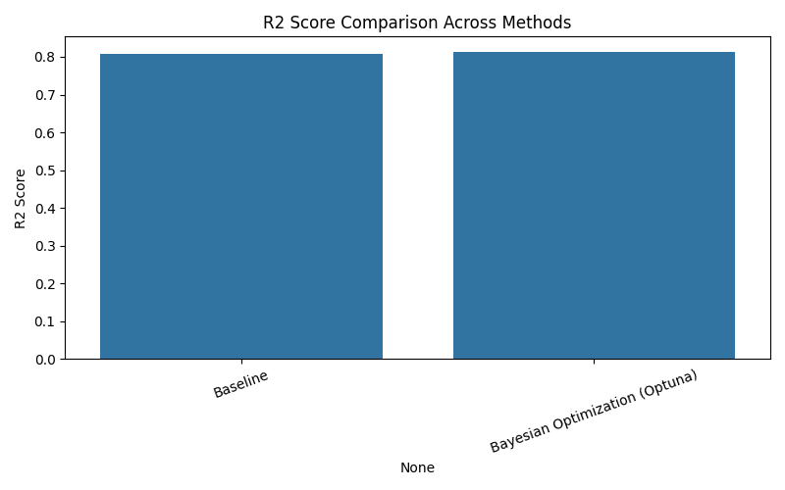
Fig 1 – R2 Score comparison
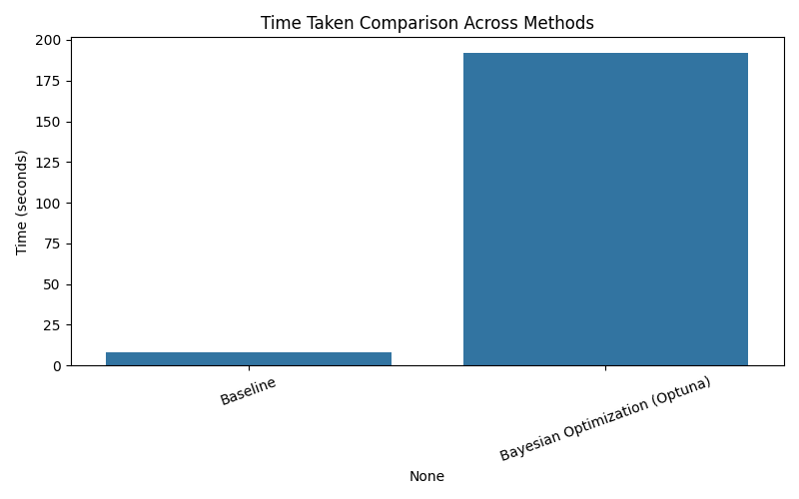
Fig 2 – Time taken comparison
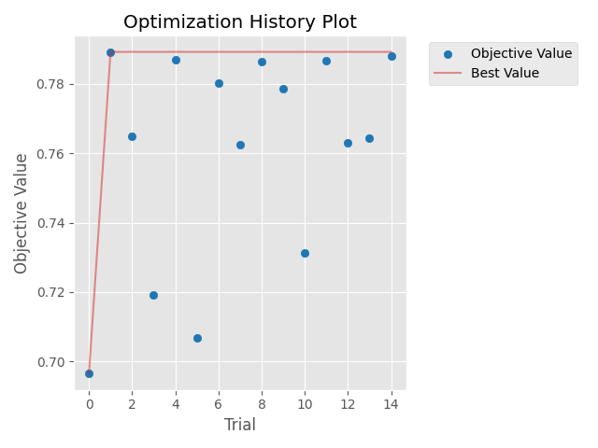
Fig 3 – Optuna optimization history
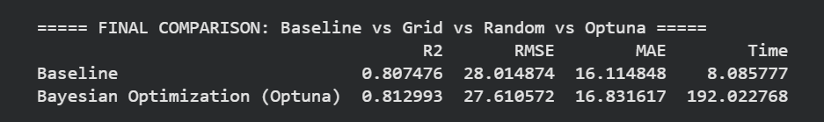
Fig 4 – Comparison Results
While Bayesian Optimization achieved the highest R² score, the improvement over the default baseline was marginal (+0.66%), and came at a significantly higher computational cost. This suggests that for this dataset and model combination, the default Random Forest configuration was already close to optimal, or that a larger number of trials may be required to find more substantial gains.

CONCLUSION
This project set out to explore how Hyperparameter Optimization and AutoML techniques can improve machine learning model performance compared to manually configured defaults, using a Random Forest Regressor trained on the Bengaluru House Price dataset. A complete pipeline was implemented — covering data preprocessing, baseline model training, and hyperparameter tuning using Grid Search, Random Search, and Bayesian Optimization (Optuna) — followed by a comparative evaluation of all methods.
Based on the results obtained, Bayesian Optimization achieved the highest R² score (0.8130) and the lowest RMSE (27.61) compared to the default baseline model (R² = 0.8075, RMSE = 28.01). However, this improvement was modest — approximately a 0.66% gain in R² — and came at a significantly higher computational cost, taking roughly 192 seconds compared to the baseline's 8 seconds. This indicates that for this particular dataset and model combination, the default Random Forest hyperparameters were already reasonably well-suited to the problem, and further gains from tuning were limited within the explored search space.
This outcome itself is a valuable finding: it demonstrates that hyperparameter optimization does not always yield dramatic improvements, and that the benefit of tuning must be weighed against its computational cost — a practical trade-off that is central to real-world machine learning workflows. It also suggests potential directions for improvement, such as expanding the hyperparameter search space, increasing the number of trials, or testing alternative algorithms (e.g., Gradient Boosting or XGBoost) that may respond more significantly to tuning.
Beyond the specific results, this project provided hands-on experience with the full hyperparameter optimization pipeline — from defining a search space and implementing multiple search strategies, to handling practical engineering challenges such as high-dimensional categorical encoding, computation time management, and reproducibility across Colab sessions. These are directly transferable skills relevant to real-world machine learning development, where automating and validating model tuning decisions is increasingly standard practice.

FUTURE SCOPE
While this project demonstrated a complete hyperparameter optimization pipeline, several extensions could deepen its findings and broaden its applicability:
- Expanding the Search Space and Trial Budget
Since Bayesian Optimization showed only a marginal improvement over the baseline within the current search space, future work could expand the range and number of hyperparameters explored (e.g., including max_features, bootstrap, or max_samples) and increase the number of trials, to determine whether larger gains are achievable with a more exhaustive search.
- Testing Additional Algorithms
This project focused on a single algorithm (Random Forest Regressor). Future work could extend the same optimization pipeline to other models — such as XGBoost, LightGBM, or Gradient Boosting Regressors — which are often more sensitive to hyperparameter configuration and may show more substantial improvements from tuning than Random Forest's relatively stable default behavior.
- Full AutoML Framework Comparison
Beyond individual hyperparameter tuning, this project could be extended by benchmarking a full AutoML framework (e.g., AutoGluon, Auto-sklearn, or H2O AutoML) on the same dataset, to compare not just hyperparameter tuning but also automated algorithm selection, ensembling, and feature engineering against the manually implemented pipeline.
- Neural Architecture Search (NAS)
For deep learning-based approaches, this work could be extended into Neural Architecture Search, automating not just hyperparameters but the structure of the model itself — relevant if the project scope is later extended to more complex, high-dimensional datasets.

REFERENCES

- https://www.kaggle.com/datasets/amitabhajoy/bengaluru-house-price-data
- Scikit-learn: Machine Learning in Python. Journal of Machine Learning Research.
https://www.jmlr.org/papers/volume12/pedregosa11a/pedregosa11a.pdf
- Optuna: A Next-generation Hyperparameter Optimization Framework.
https://dl.acm.org/doi/epdf/10.1145/3292500.3330701
- Scikit-learn Documentation, "GridSearchCV,"
https://scikit-learn.org/stable/modules/generated/sklearn.model_selection.GridSearchCV.html
- Scikit-learn Documentation, "RandomizedSearchCV,"
https://scikit-learn.org/stable/modules/generated/sklearn.model_selection.RandomizedSearchCV.html
- Practical Bayesian Optimization of Machine Learning Algorithms," in Advances in Neural Information Processing Systems (NeurIPS)
https://proceedings.neurips.cc/paper/2012/file/05311655a15b75fab86956663e1819cd-Paper.pdf

